Combat Pediatrics – The Experience at Hoa Khanh
By
CDR Charles C. Spear NC USN (Ret)

All color photography by the author

I was little more than a spoiled, selfish, and self-centered teenager in the summer of 1966. I had barely graduated from high school and was unprepared for college academics. Living in a small-town South of Boston, my father kept me keenly aware of my military draft eligibility! I doubt I could have found Vietnam on a world map, but I had heard young American men were dying there. Thus, with no other interest beyond self-preservation by avoiding the draft, I enlisted in the U.S. Navy.

I have never forgotten my Navy recruiter. With a boisterous, “Look at the opportunities in this man’s Navy, son!” he handed me a chart of “rating” symbols and their corresponding job descriptions. Truth be told, I had no interest in any military occupation. As a “Boiler Tender” or “Machinist Mate,” I could only envision being deep in a dirty engine room shoveling coal. At some point I must have recognized the medical caduceus insignia and inquired (“Now that’s a great choice! Nice white hospitals… pass a few bedpans… and best of all, nurses to fool around with!”). In August, with little or no forethought, I became a Navy Medical Corpsman Recruit. The Navy corpsman of the 1960s could be compared to a cross between a licensed practical nurse (LPN) and an emergency medical technician (EMT) in today’s healthcare environment. On ships at sea and Naval hospitals ashore, the function of a corpsman is to provide both basic nursing and emergency medical care. Corpsmen could also select advanced specialty training and, for example, become laboratory, operating room, or pharmacy technicians.

I would complete recruit training (aka “boot camp”) at Great Lakes, Illinois, followed by the Basic Naval Hospital Corps School. Upon reporting, I was casually told I would eventually be headed for the Marine Corps Base at Camp Lejeune in North Carolina for “combat training”. That recruiter! He had failed to inform me the U.S. Navy supplied the Marines with all their medical personnel! It was now too late to turn back! The escalating war in Vietnam, with the subsequent increase in casualties, had put pressure on the supply of field-trained medics for the Marines and the Navy Medical Department as a whole.

In the interim, before departing for Southeast Asia, a variety of clinical experiences helped to shape my future health care career. My first, non-training duty assignment was to the nursing service at the Naval Hospital, Roosevelt Roads, Puerto Rico. In 1967, “Rosey” had an exceptional Chief Nurse, Commander Kathryn Zabel. With foresight and a personal interest, she made a significant effort to rotate all newly minted corpsmen through a variety of hospital experiences – including the patient wards, the emergency and operating rooms, the pharmacy, and even the nursery. A three-month nursery assignment for a future Marine medic! What did she know? And how much it would play into my Vietnam future. I would also discover an affinity for patient care. A year later my uniform would change from Navy blue to Marine Corps green. (Note: In 1979, as a Navy Nurse Corps Ensign, I bumped into now Captain Zabel at the National Naval Medical Center, Bethesda, Maryland. One did not hug a Captain in those days, however I profusely thanked (and verbally embraced) her for contributing to my professional development, personal achievement, and a lifetime career path. She was not alone. There were other Navy nurse mentors whose names I wish I could remember. The recruiter had not been far off after all).

I arrived in Da Nang in early November 1968 and was initially assigned to the 1st Force Service Regiment (1st FSR), a logistical component of the 3rd Marine Amphibious Force. I would spend my first weeks “in country” with a Marine security platoon riding convoys throughout I Corps - the Northern most sector of South Vietnam for which the Marines were operationally responsible.

While attending Field Medical Service School at Camp Lejeune, I had become focused on Vietnam, the ongoing war, and the innovative attempts by the Marine Corps to win the “hearts and minds” of the Vietnamese population. I would also attend a rudimentary Vietnamese language and culture course. With no traditional “front,” defined battle lines, or an easily identifiable enemy, the conflict in Vietnam had, from the onset, been characterized as a “guerrilla” war. In a departure from historical combat roles and tactics, the Marine Corps quickly realized the importance of gaining civilian trust and loyalty. Starting at the local level, and with the development of Civic Action Programs (CAP), the Marines furnished a wide variety of technical, material, and medical support and assistance to Vietnamese communities. The comparison of the Marine’s CAP to the Peace Corps was not a far stretch. The Medical Civic Action Program (MEDCAP) was one of the most successful and a children’s hospital would become its shining star.

Many Marine Corps units supported a MEDCAP as part of their operational function. On my first “days off” I volunteered with 1st FSR’s MEDCAP team and ventured into rural villages and hamlets to provide basic health care and education to a population with no previous exposure to Western medicine. It was amazing what could be cured with a bar of soap, iodine solution, and aspirin. One afternoon our team happened across a severely ill and dehydrated Vietnamese toddler. I was directed to act as a liaison and escort both the child and her family to the MEDCAP children’s clinic/hospital located at the entrance to Camp Books – at the edge of the village of Hoa Khanh. I remember carrying her into the facility and immediately deciding that working in civic action might be the best contribution I could make to the war effort. After submitting a formal request and being interviewed, I would be permanently assigned to the Hoa Khanh Children’s Hospital (HKCH).

As fighting in the rural countryside escalated throughout the 1960s, the area in and around Da Nang, including Hoa Khanh, experienced a massive influx of refugee families and the rapid growth of impoverished settlements and shanty towns - most without running water, electricity, and basic sanitation. Once an agrarian community, Hoa Khanh’s rice paddies had been drained to accommodate refugee housing. Resettlement homes, often little more than a single room for an extended family of three generations, were constructed of plywood, corrugated tin, and castoff U.S. shipping materials. Local disease, insect and rodent control were non-existent. Human congestion, a complete lack of modern medical care, and an ongoing war combined to create a public health nightmare.

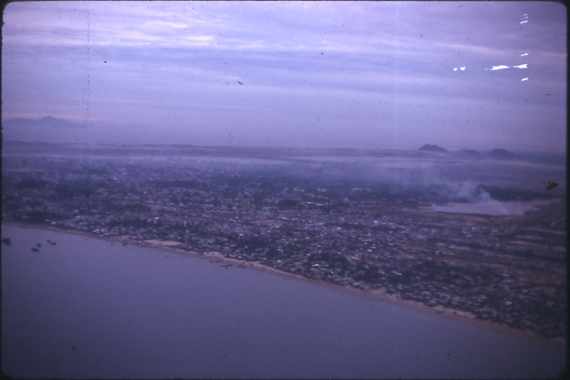
Flying North along the coast from Da Nang

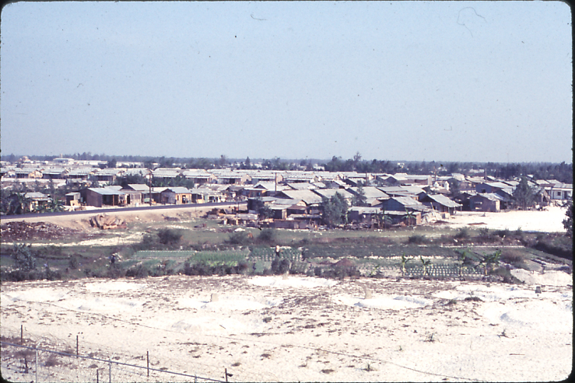
Refugee housing in the village of Hoa Khanh

Initially established as a small roadside clinic by two Navy physicians in 1965, the Hoa Khanh Children’s Hospital grew from basic outpatient care services to an 11-bed inpatient facility in 1966 and had expanded to 70 beds by 1967. Pediatric patients came from throughout all of I Corps – within an estimated civilian population of 2.6 million. We were certainly the major and, in reality, the only dedicated pediatric facility in the entire region. Between 1966 and late 1969, HKCH treated more than 20,000 children - including as many as 5,000 seriously ill or critically injured inpatients.
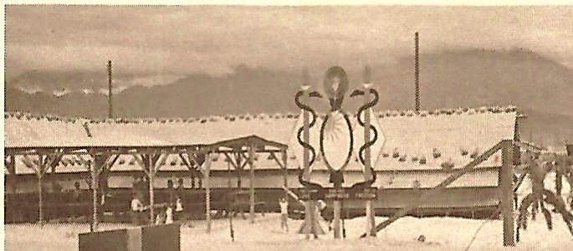
The Hoa Khanh Children’s Hospital, circa 1967 (USMC photo)

When I reported for duty at HKCH, it was easy to be overwhelmed. There was a single open-bay ward now housing up to 100 sick and injured children, a combination emergency and treatment room at one end of the building, and a makeshift operating room at the other. There was a simple “nursing station” for preparing medications and intravenous (IV) solutions. The need for bed space had become so critical that shelves had been built into the walls (albeit devoid of mattresses and pillows). At night, many children were simply bedded down on the floor. IV bottles hung from rafters or from wherever one drove a nail. There was a single sink with running water and no indoor toilets. The roof leaked. There were rats.

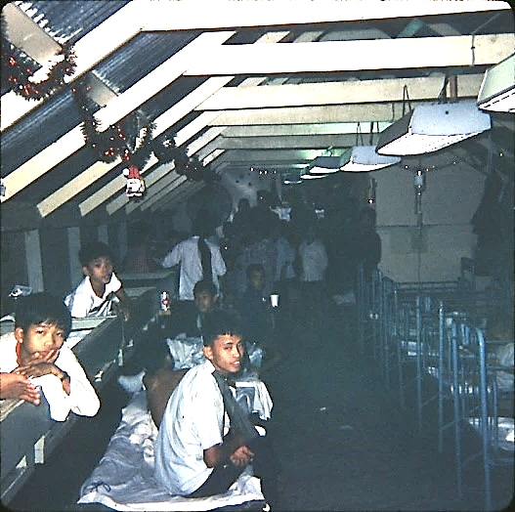
The main ward of the original Hoa Khanh Hospital
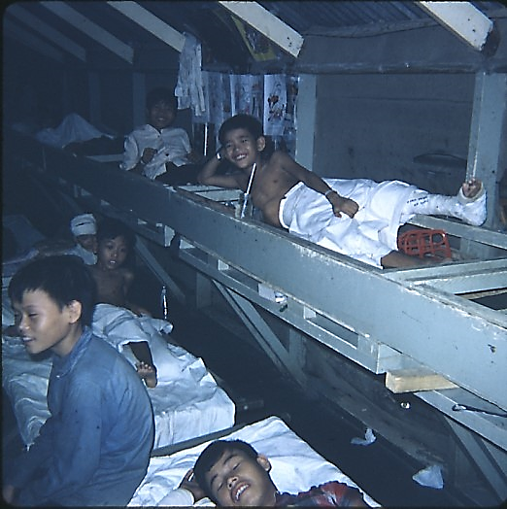
Patient “shelving”
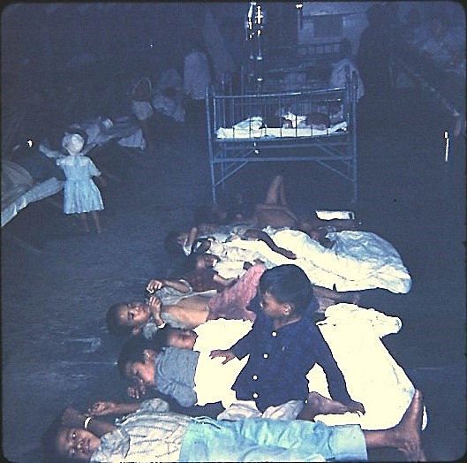
Bedtime on the floor
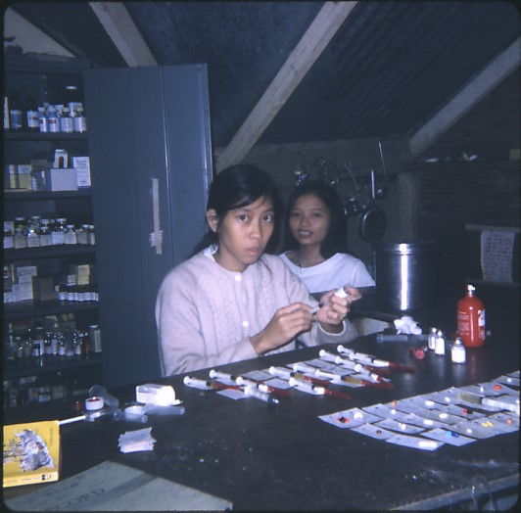
The nursing station and medicine preparation
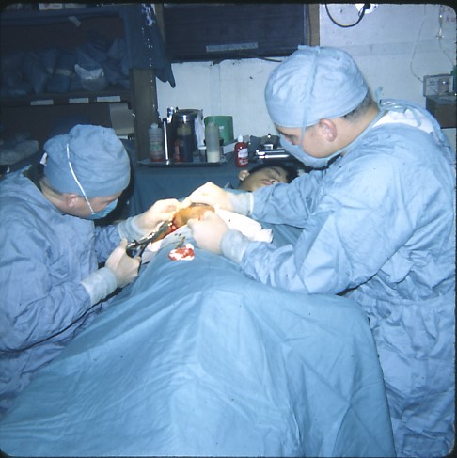
The operating room

Despite the lack of sophistication, HKCH met a tremendous regional need. While we did not have the time or ability to keep detailed statistics, routine inpatient admissions consisted of (1) endemic tropical diseases (malaria, bubonic plague, encephalitis, typhoid, tuberculous, and parasitic infections being common), (2) major orthopedic injuries, (3) severe 2nd and 3rd degree burns, (4) generalized trauma, (5) localized and systemic infections, (6) fevers of unknown origin, (7) miscellaneous illnesses not always easily defined or diagnosed and (8) war-related injuries and wounds. With very limited (and not always timely) laboratory testing, a diagnosis was largely based on a child’s physical condition and symptom presentation. We did have X-ray capability and a skilled Vietnamese X-ray technician.

We were fortunate to have multiple medical resources and activities supporting the Children’s Hospital. Most notably were the Navy Hospital Ships, Repose and Sanctuary, and the 1st Medical Battalion near Da Nang. During periods of low combat casualties, children in need of emergency or elective surgeries could be referred to all three (via jeep, ambulance, and boat launch). Both hospital ships maintained small wards for Vietnamese children, many of whom were sent to and from HKCH. All military medical units in the region willingly shared their medical supplies and equipment with us. Utilizing HKCH informational brochures published by our Marine chaplains’ office and sent to U.S. charitable organizations, pharmaceutical companies, and medical equipment manufacturers, we received needed and welcomed donations. Parents and spouses of the American hospital staff also assisted (After burning through our only electric cast saw, my mother wrote to the Stryker Cast Corporation, which sent us two!). Private donations of children’s clothing were always appreciated and probably shipped to us at considerable expense.

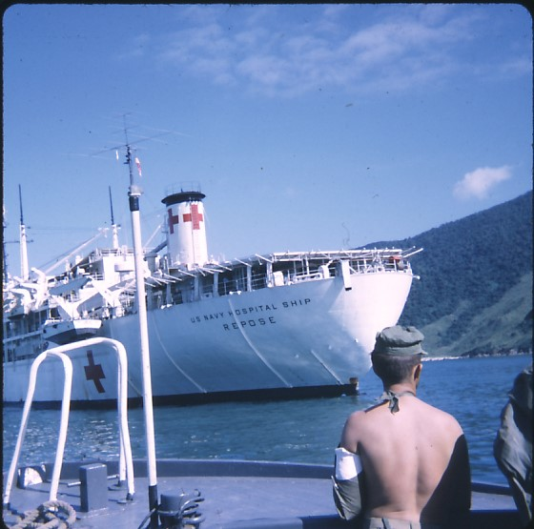
The US Navy Hospital Ship Repose

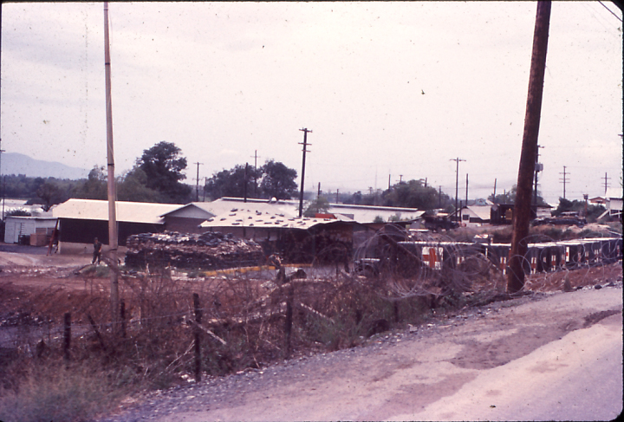
The 1st Medical Battalion near Da Nang

By 1968 the original clinic building had quickly become completely outgrown, crowded, and beyond dingy. Construction of a modern hospital facility, designed for a 120-bed capacity, started in the same year and opened in January of 1969. Built entirely of stone and tile, it was funded with cash donations from individual Marines with building materials provided by the Vietnamese and solid construction by the Navy Seabees. In addition to a large, well-lit, and centrally located open ward, there was a nursery, four isolation rooms, multiple treatment and procedure areas, a pharmacy, emergency and operating rooms, and a functional sterile supply with a full-size sterilizer/autoclave. The all-tile interior meant the entire building was much easier to clean (and keep clean!), and undoubtedly helped to resolve the “rat problem.”

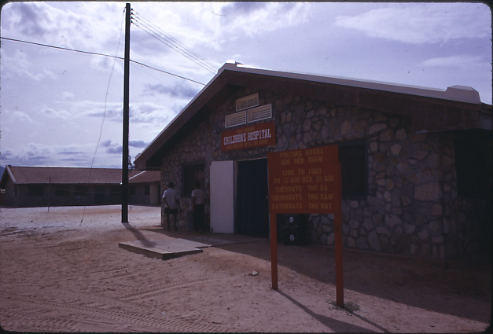
The “new” Hoa Khanh Children’s Hospital, January 1969

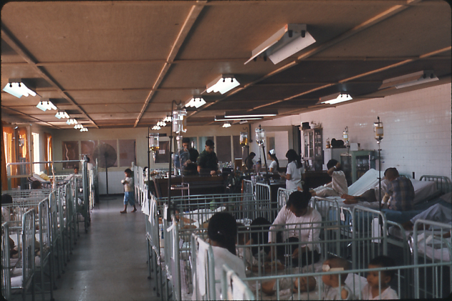
The main open ward – with the glassed-in nursery at the rear

The operating room may have been one of the most modern in all Southeast Asia. The operating theater lights certainly were – donated by American Hospital Supply Corporation.
One day we received an entire surgical field hospital that had been found in storage and shipped to Hoa Khanh – a treasure trove for our operating room technician!

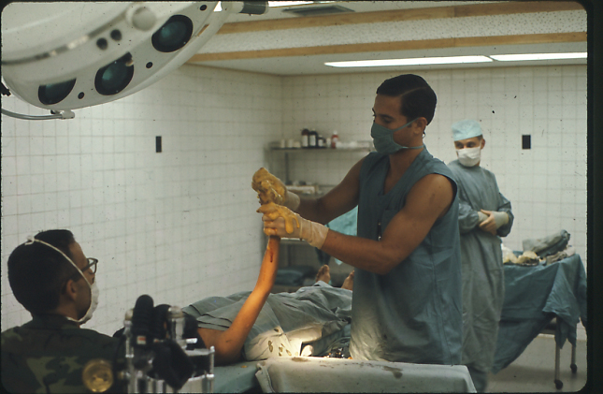
The modern operating room with a visiting surgical team from the 1st Medical Battalion

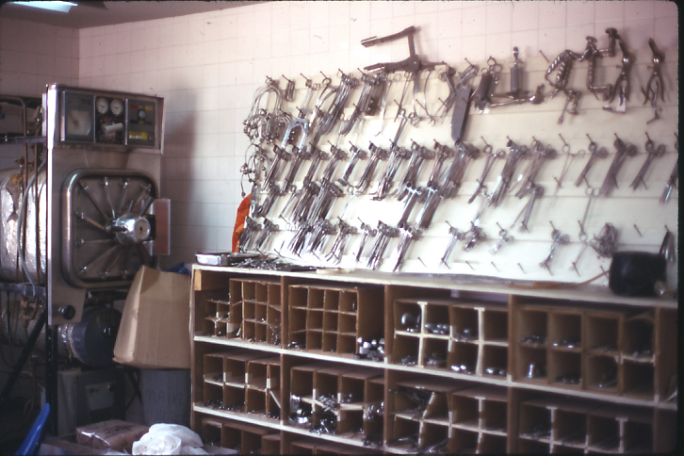
The sterile central supply including a large functional autoclave

The hospital also had a dining room for ambulatory patients. The photos below show a study in contrast between the old and the new Hoa Khanh “dietary services.” Food was not prepared on site. The galley for the Marine Logistics Command cooked enough extra hot meals to feed up to 120 children - three times per day. We were fortunate to have a dedicated Marine driver to transport multiple bulk food carriers back and forth for each meal. There must have been a bit cultural shock over the food selection, but our hungry and healing children never complained – at least that we knew of!

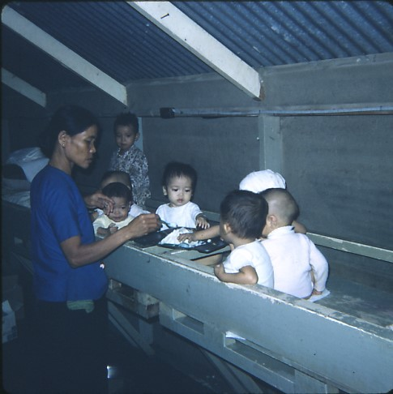
Dining at the “old” hospital – one plate, one pile of rice, one spoon, and five children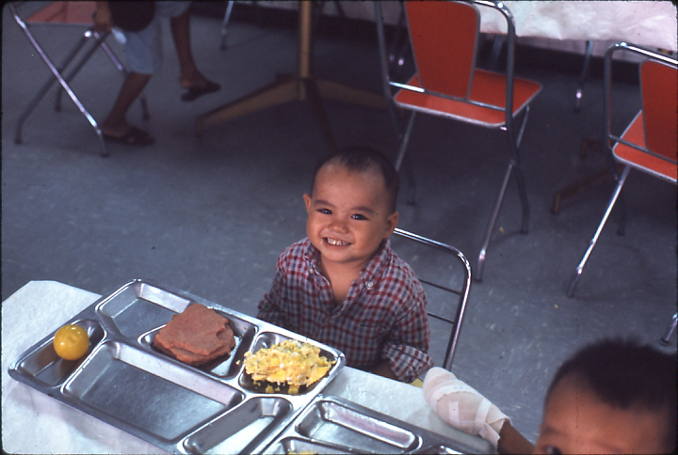
In the “new” dining room – and a gratuitous smile for Spam and powdered eggs?
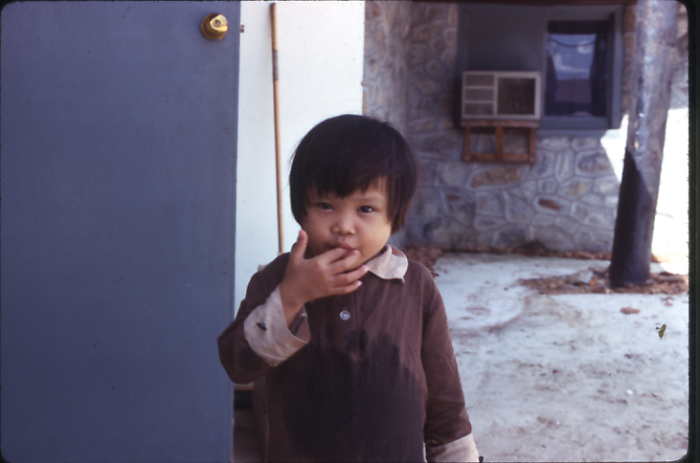
And now and then – a “yum”
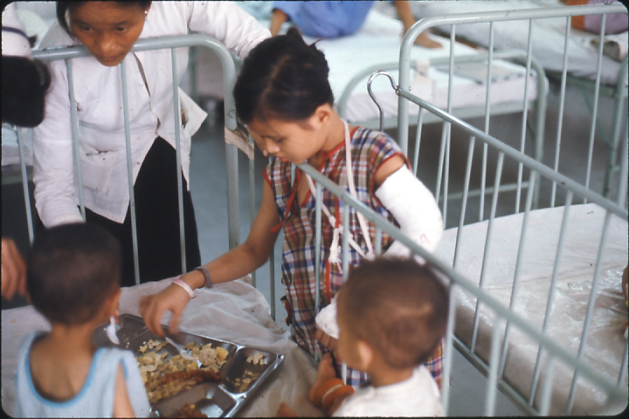
Everyone, including patients, pitched in to help feed those who could not feed themselves

The Navy staff had also grown and now consisted of seven full-time corpsmen, an admin chief, and three part-time physicians assigned to the nearby Camp Books dispensary/aid station. At least one of the physicians would make daily rounds and write orders on the most seriously ill/injured and/or newly admitted children or those ready for discharge. Approximately 70 paid Vietnamese nursing, secretarial and housekeeping personnel were hired from the local community. Only a few had any formal nursing education. For the remainder it was learning on-the-job. The corpsmen lived on the hospital compound 24/7 and served to support, assist, and train the Vietnamese staff, as well as provide direct nursing and emergency medical care. Fortunately, several of our Vietnamese nurses understood and spoke English.

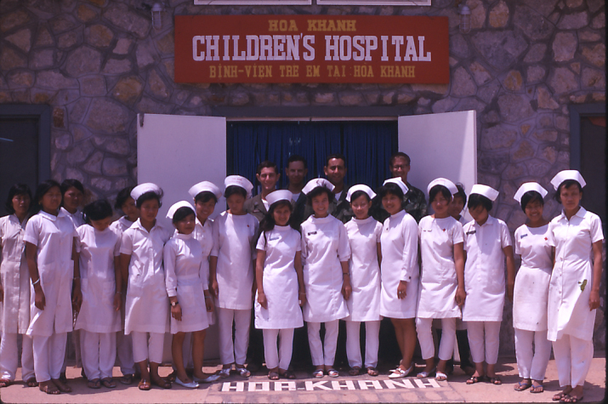
The Hoa Khanh nursing and medical staffs, January 1969
I cannot begin to say enough about the dedication of the Vietnamese nursing staff, starting with our Head Nurse, Nguyen “Gwen” Thi Khang. Gwen was at HKCH from its inception when the Marines were seeking a local medical interpreter. Originally from North Vietnam, she had migrated to the South in the refugee evacuation of 1954 when Vietnam was divided. She had always been determined to become a nurse. Not only did she display knowledgeable patient care skills, she was also an excellent manager. With her near fluent English, she could cross communication and cultural barriers and guide the American doctors and corpsmen as easily as she did the native nursing staff, patients, and families. The hospital had one strict rule for inpatient admission and treatment - parents and/or family members could not remain at the bedside with their children as was customary in Vietnamese hospitals. While we did allow for two-hour visitation on Tuesday and Thursday afternoons, leaving their children with us was understandably difficult for many parents. It was often Gwen’s gentle and convincing negotiating skills that saved more than a few lives. On occasion, I recall families refusing to have their child admitted and deciding to return home with a dying child - who we potentially might have saved. Dealing with a predominantly rural, uneducated, and superstitious population was always a challenge. Gwen could bridge that gap. She would gain world-wide recognition.

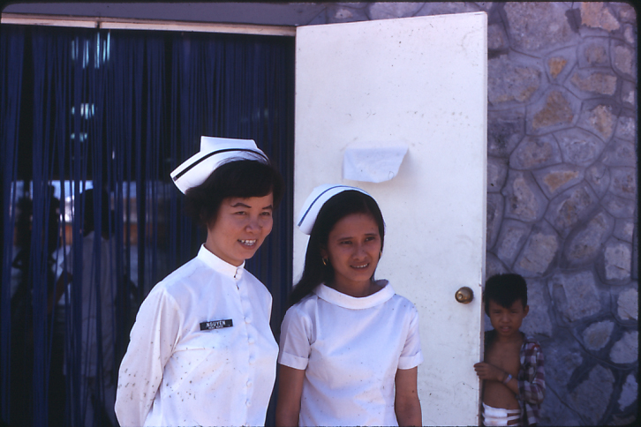
Head Nurse “Gwen” Thi Khang (left) and Assistant Head Nurse “Sandy”

Inpatient stays were routinely extended beyond a child’s initial recovery to insure a full regime of prescribed treatment. For example, if an infectious process required two to three weeks of oral antibiotics, the patient would remain at Hoa Khanh until the course was complete. In addition to being able to monitor a child’s recovery health, families could not always be trusted to continue administering medications after discharge, particularly when the child would appear completely well.

A close cousin to MEDCAP was the Dental Civic Action Program (logically… DENTCAP!). Navy dentists, with military and Vietnamese hygienists, would routinely visit Hoa Khanh to conduct oral examinations, treatment, and encourage preventive care for our ambulatory patients. I always wondered how many Hoa Khanh children had actually seen a toothbrush before… and if it found better use at home after discharge.

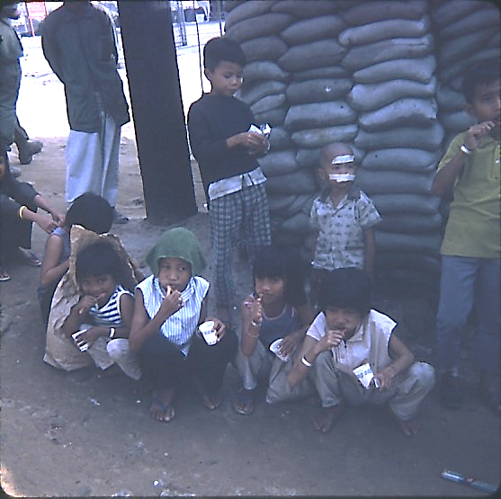
Tooth brushing instruction at our “modern” outdoor lavatory

It should be noted we did have one bathtub - for 120 patients! While we originally strived for “bath nights,” we rarely had enough water pressure to fill the tub!

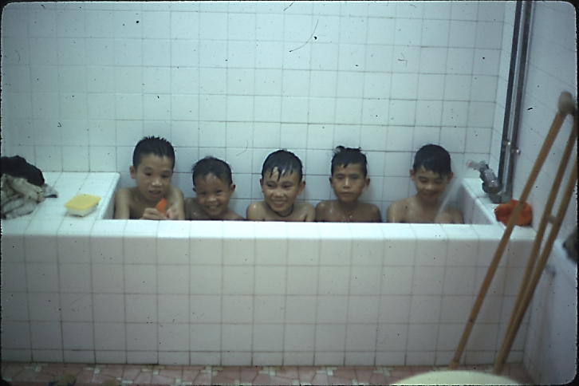
Maximizing water usage!
Although Hoa Khanh was a medical refuge, the war was as endemic as tropical disease. There were nights when flares were continuously launched over the local villages from sunset to sunrise with a gunship circling overhead. The weather could be equally threatening, with monsoon rains and scorching tropical heat. The emergency and operating rooms had limited air-conditioning. The main ward did not!

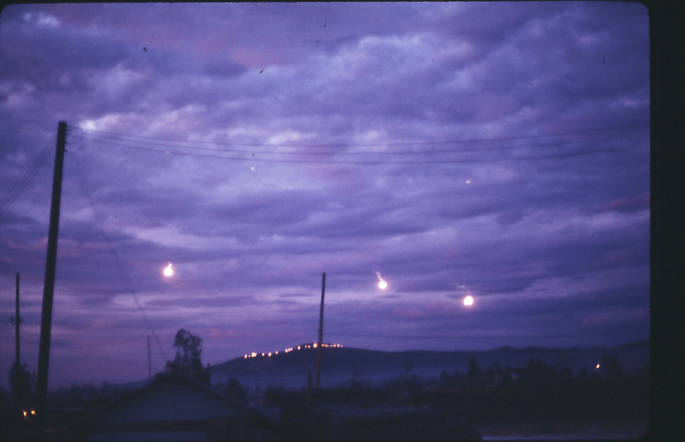
Flares over Hoa Khanh and the “all night day”

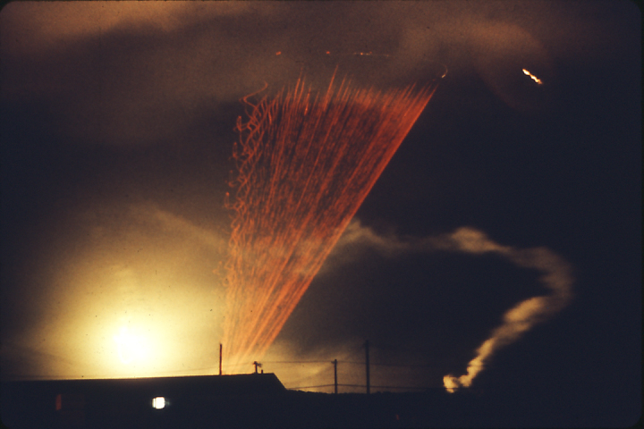
A gunship circling in the night sky (with red “tracer” bullets from air to ground)
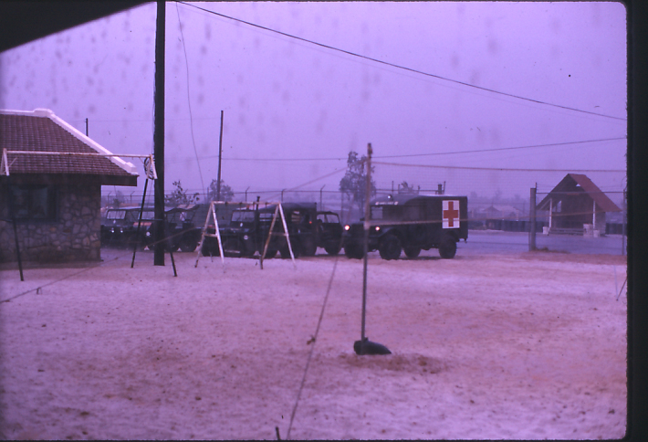
Monsoon season – which did not slow down patient arrivals

Our children were extraordinarily resilient, despite illness, injury, and a war from which they could not escape. While the staff did not have the time for much play, we promoted laughter and fun whenever possible. A donation of a case of Fizzies (an add-water, carbonated-flavored drink-tablet popular with Marines to plop into their canteens) could lead to an evening “Fizzies Party.” The hospital frequently received donations of toys and games, particularly at Christmas. We had swing sets on the compound and utilized the hallways as play areas (necessary during the monsoon!).

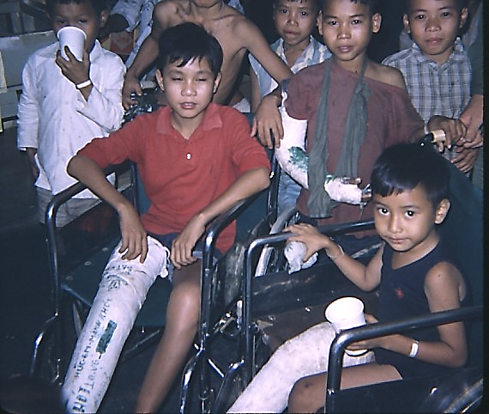
A” Fizzies Party”

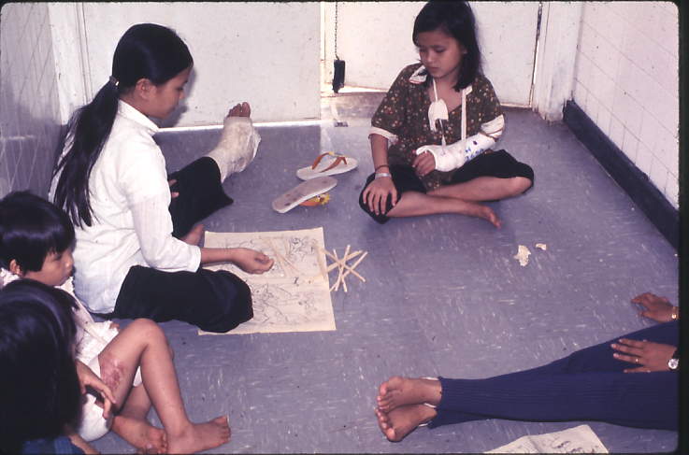
Playing pick-up-sticks in the hallway

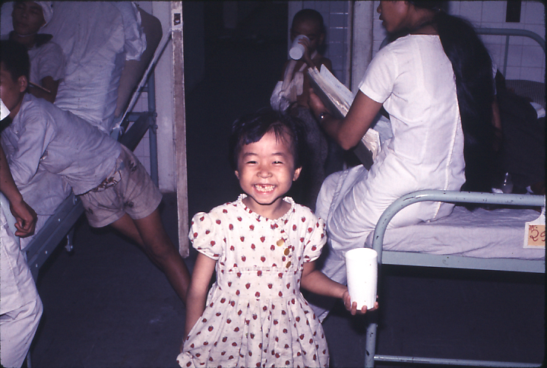
Celebrating a lost tooth – was there ever a Vietnamese tooth fairy?

Caring for 120 children was no simple task and innovation was a necessity. First, was the complex matter of identifying each individual patient, particularly when so many Vietnamese children had similar names or were too young, too ill, or too injured to respond if questioned or called. Upon admission, each child was assigned a specific number to which everything else would be keyed… an ID bracelet, a bed tag, a simple medical record/chart, a TPR (Temperature, Pulse and Respiration) graph and the NAVMED (Navy Medicine) Medicine and Treatment Cards - for those who remember the small cards upon which medications, treatments and their corresponding times were transcribed. We were fortunate to have two wonderful Vietnamese “secretaries,” Ahn and Phuong, who tirelessly kept the entire inpatient population (and the staff!) somehow organized.

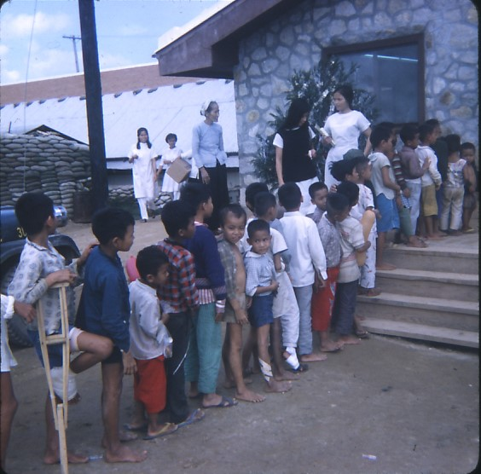
Sick call? Immunizations? A head count? Or Santa Claus? Our walking wounded!

Tropical, communicable, and parasitic disease accounted for the majority of inpatient admissions. Some parasitic diseases were obvious. Others were not so easily diagnosed. In the picture below is a young boy with a severe human itch mite (scabies) infestation of his scalp.

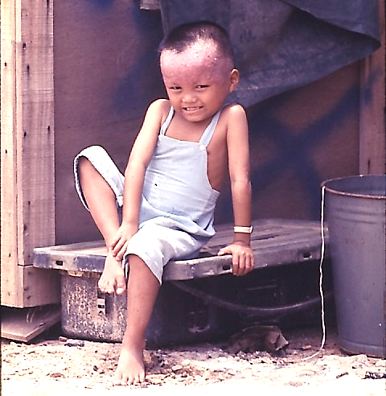
Severe scabies

How he could hold still to be photographed I am not sure. The pruritis alone must have been maddening. If we had Kwell shampoo or lotion in stock, we would have initially treated his scalp and then followed up with a “Betadine beanie” to reduce infection/inflammation. The extent of his infestation would have resulted in an inpatient stay for at least several days.

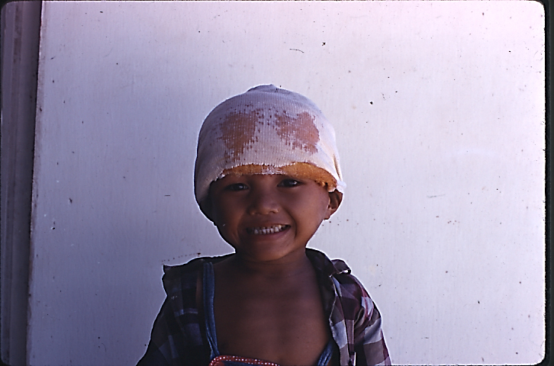
Scabies treatment with a ‘Betadine beanie”

Wounds and wound infections, both large and small, brought many families to seek care at Hoa Khanh. In addition to cleansing, disinfecting, and debriding, the use of antibiotics, whether oral, injectable, or intravenous, was often nothing short of miraculous. Hoa Khanh patients were the first generation of Vietnamese to be treated with not only staples such as penicillin and tetracycline, but broad-spectrum antibiotics as well. Since we did not have on-site microbiological culture capability, an antibiotic “shotgun” approach might be tried. The foot infection below may have resulted from an insect bite. However, by the time of emergency room presentation, it had become full-blown cellulitis.

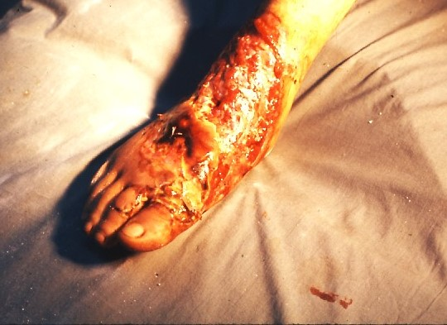
Severe cellulitis of the foot

I can assume this patient was placed on antibiotics in some form for several weeks (or more) along with aggressive wound care.

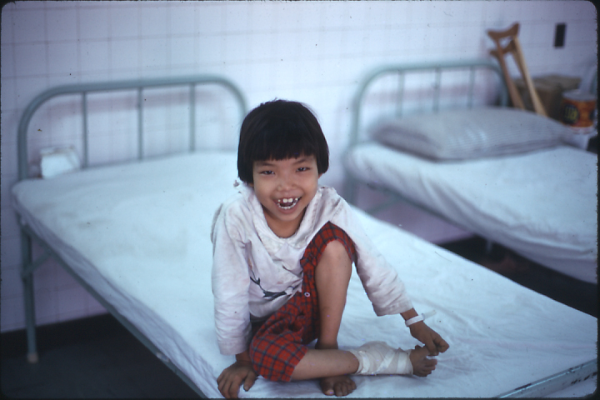
The miracle of antibiotics – awaiting discharge with a smile!

By far the busiest spot in the hospital was the “Treatment Room” dedicated to wound care and dressing changes. Open, actively bleeding, and/or draining wounds were checked daily. I am sure we used povidone-iodine solution by the gallon. Again, as with most first-time bacterial exposure to antiseptics, bactericides and topical antibiotics, healing response was amazing.

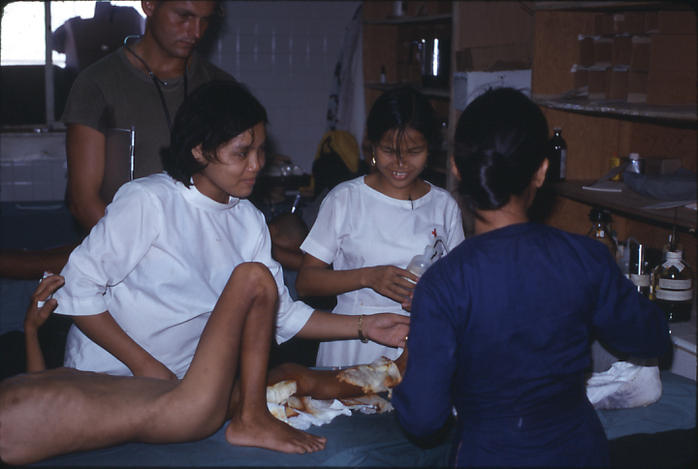
The dressing change and wound treatment room
Several corpsmen and Vietnamese nurses become very skilled wound managers. They also knew their limits and would not attempt extensive abdominal, chest or cranium exploration, however wound cleansing, debridement, and closure, when possible, was the routine.

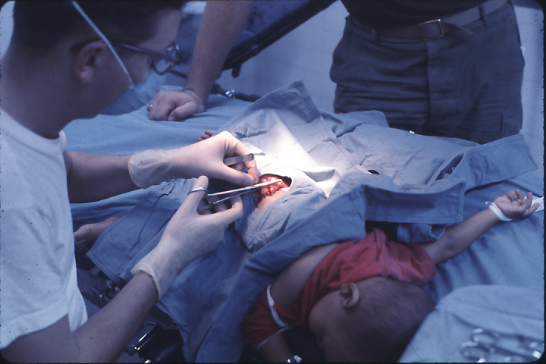
Corpsman closing a shrapnel wound of the hip following debridement and cleansing

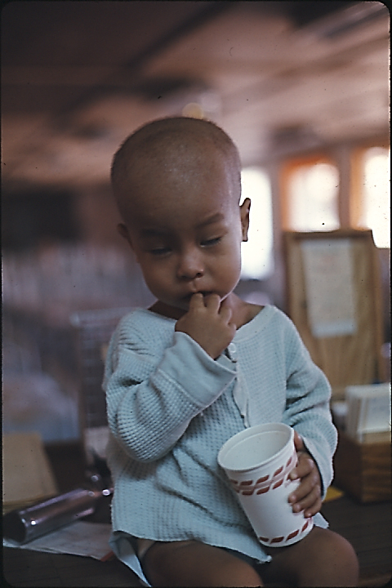
The above patient – recovering
One surgical procedure performed by almost everyone was the “IV cutdown.” A sutured-in-place IV canula was our only option for retaining a long-term intravenous line in small children. Scalp vein (“butterfly”) needle placement was useless in our situation. A cutdown line could remain in place up to a week before evidence of phlebitis or infection. It was truly a lifesaving technique for a young, sick, and dehydrated child, especially when veins could be far too small for traditional venipuncture/IV “intracath” insertion.

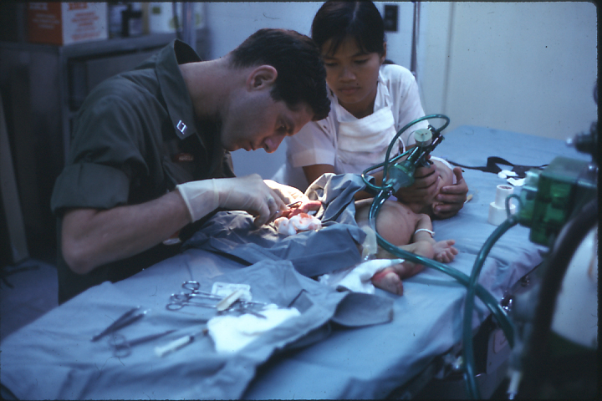
Teaching an IV cutdown

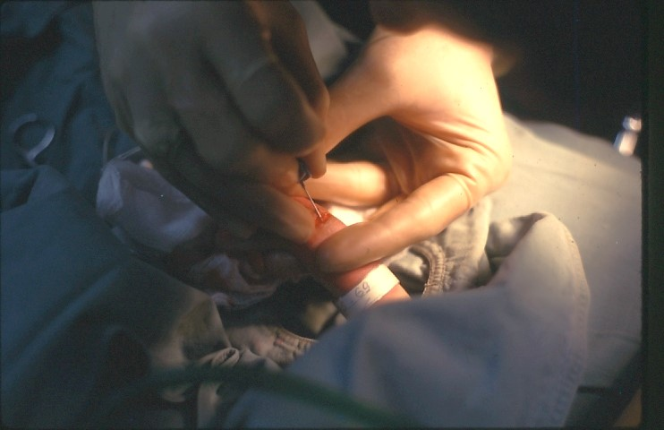
Canulating a tiny vein via cutdown

Burns, both 2nd and 3rd degree, or in combination, were the greatest care challenge at Hoa Khanh. The primary cause for childhood burns was due to exploding cooking fires when gasoline would become confused with kerosine. This was a common accident in rural communities where multiple types of flammable liquids were previously unknown. The priority with the most serious pediatric burns was to ensure stabilization with intravenous fluids and then regularly debride and dress the areas of burnt tissue that remained. Fortunately, we had access to two of the best topical burn agents at the time, Xeroform Gauze and Silvadene Cream.

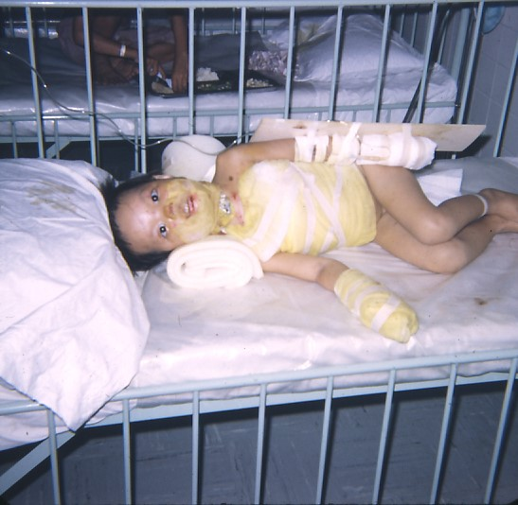
Ten-year-old girl with second degree burns of face, chest, abdomen, and hands

The girl in the photograph above was in respiatory distress during admission and required a tracheostomy.

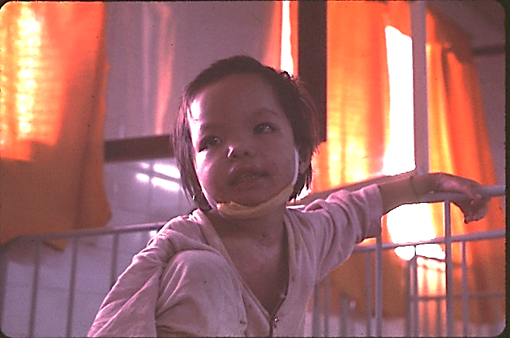
Same burn victim recovering
One Sunday afternoon, and probably one of our worst hospital days, six teenage boys arrived simultaneously to the emergency room following a massive gasoline explosion. Four presented with 2nd and 3rd degree burns greater than 60% of their bodies. Three of the four died within 24-48 hours of admission in spite of heroic efforts. The one (of the four) who survived developed multiple secondary problems, including muscle contractures of both legs and an arm. The entire staff gained significant knowledge of severe burn care throughout his admission. Eventually, he was transferred to one of the hospital ships for skin grafting and contracture release and correction.

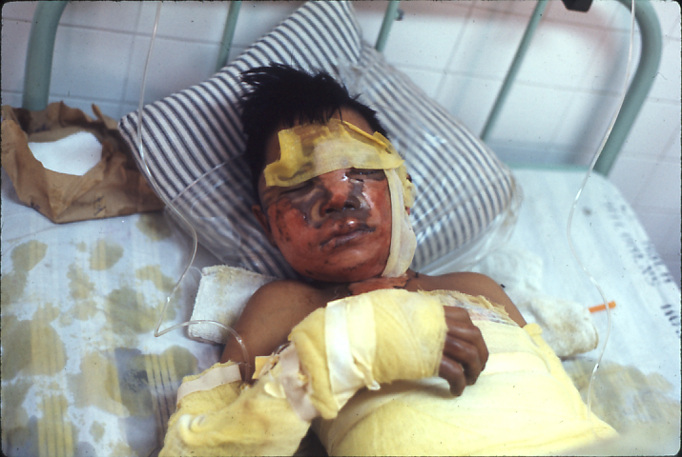
2nd and 3rd degree burns (+/- 80%) - fluid/electrolyte balance always a concern
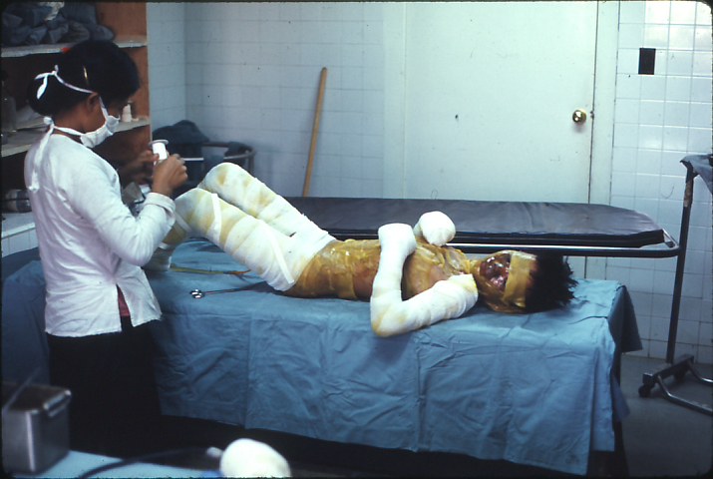
Daily dressing changes with Xeroform Gauze
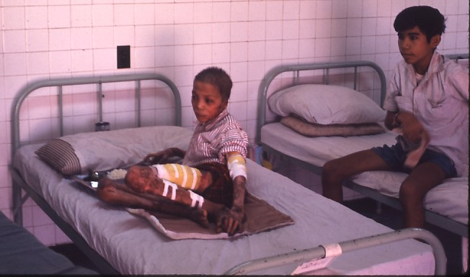
Approximately three months after 2nd and 3rd degree burns – a Hoa Khanh success story

Pediatric orthopedic injuries accounted for the major portion of our trauma admissions. A prime contributor to broken bones being the lack of milk and other calcium rich foods in the Vietnamese diet. Long bone fractures were most common, particularly those of the femur. Our primary treatment would be short-term traction and then plaster casting when bones were determined to be in apposition. For younger children, depending on age and weight, the technique of Bryant’s (or “gallows”) traction, suspending the child by his or her legs until stable bone alignment, followed by application of a full or half hip spica cast, was a care option. Frequent pedal-pulse/circulation checks were necessary.

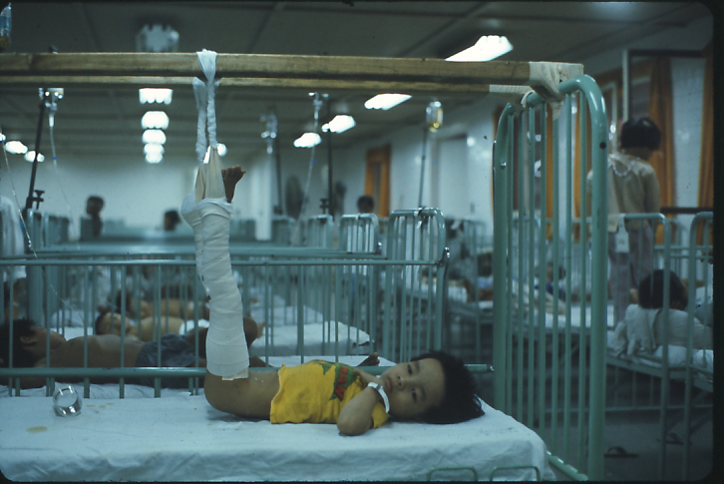
“Gallows” traction for a fractured femur

Older children with femur fractures were, when possible, treated with weighted skin (Buck’s) traction until good alignment was achieved and the application of a hip spica cast - not the most pleasant appliance to wear in 90-plus degree heat!

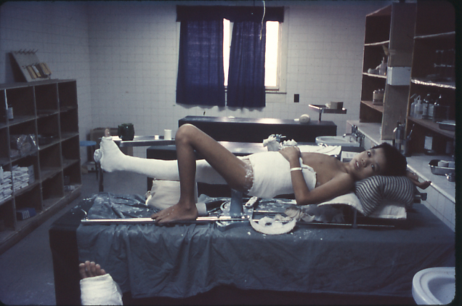
The dedicated cast room with a hip spica application support frame

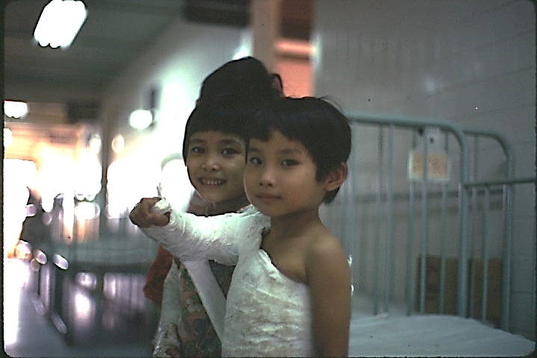
“Creative” plaster casting… whatever worked!
Plaster cast and splint utilization at Hoa Khanh became a creative art as frequent cast application and changes were always necessary. Traditional Plaster of Paris was the only casting material available to us. I should make note that several corpsmen developed individual “specialties.” I tended towards orthopedics and spent many hours in the cast room in addition to my nursing duties. An operating room technician was always assigned to Hoa Khanh to assist with surgical procedures or, within the limits of his experience, perform minor surgery. Additionally, he maintained the operating room and the preparation of all the sterile supplies and surgical equipment used throughout the hospital. Another corpsman was responsible for the emergency room, although everyone responded to patient emergencies when needed. Our “supply corpsman” rarely participated in patient care as he was far too busy procuring the daily medicines and equipment required to keep the entire facility functioning – a job requiring great skill and tact when “begging” for medical supplies from units throughout in the region!

With a fully functioning operating room, orthopedic surgeons from the 1st Medical Battalion could come to Hoa Khanh to perform elective repairs.

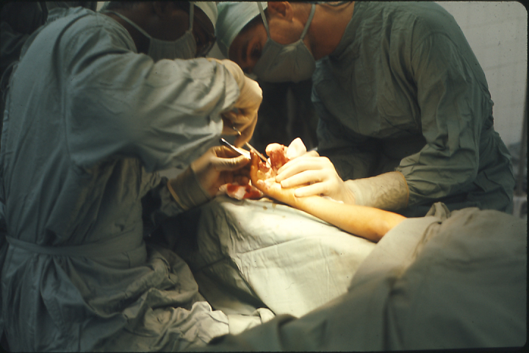
1st Med Battalion hand surgeon performing a hand rebuild

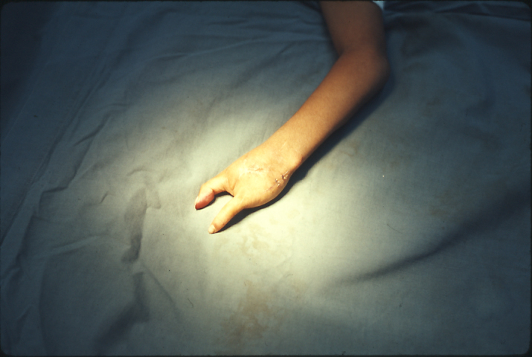
And a result
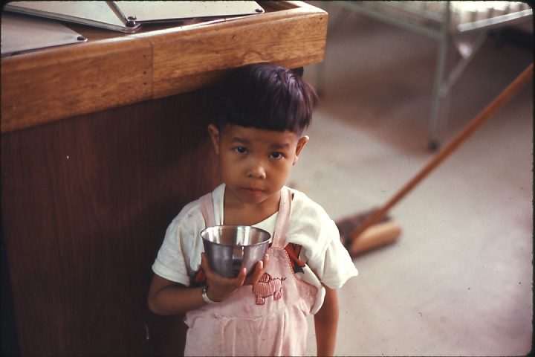
Hand repair patient in above photo

Hoa Khanh truly had “miracle” patients. The girl pictured below sustained severe crush injuries to both arms, reportedly having been caught in the tread gears of an armored vehicle! The accident occurred within a close enough proximity to the hospital that we were able to stem her blood loss, pack her arms in ice packs, and MEDEVAC her to the 1st Medical Battalion where a surgical team was waiting. She would recover with us and develop an addiction to Kellogg’s Corn Flakes. I would dub her, “The Corn Flakes Kid”! She regained limited, but very adequate, function in both arms.

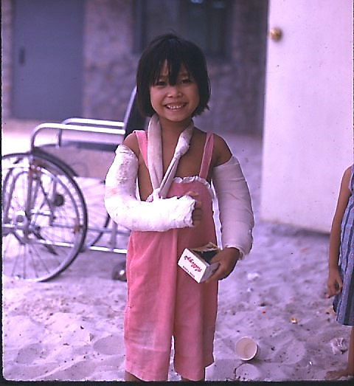
Miss Corn Flakes of 1969!
Although there was no set daily schedule for the corpsmen per se - everyone simply worked until the day’s tasks were completed - there was always one night corpsman assigned from 1900 to 0700. During one of my night tours, I received two small children (a brother and sister, as we would learn later) who had been found living in a bomb crater near the DMZ and literally “eating dirt.” As a result of severe malnutrition and vitamin deficiency, both presented with a gangrenous stomatitis called noma - a rapidly progressive disease/infection of the mouth and face in young children and with a 90% mortality. Both had very high fevers. I had no idea of the diagnosis. I radioed the physician on duty at the aid station and described their symptoms. Gangrene was extensive around their mouths/gums. I was advised to start IV fluids, cool them with wet towels, and debride to the best of my ability. I still recall the emotions of excising the lips, teeth, and gums of two young children - and literally ruining their faces. The sister would die the following day.

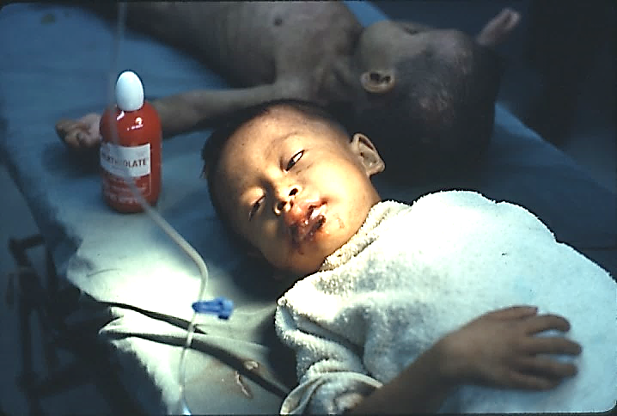
A brother and sister admitted with noma

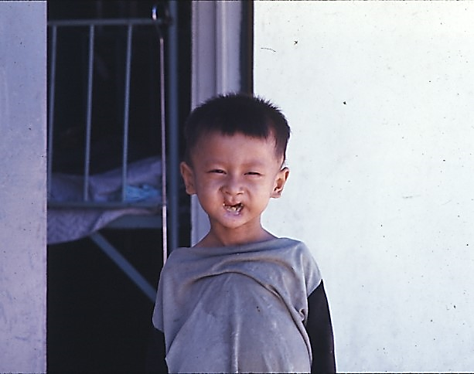
A noma survivor and another Hoa Khanh “miracle”
“Noma Boy,” as we affectionally nicknamed him, recovered, and was later admitted to one of the hospital ships where oral surgeons reconstructed his mouth and lips.

Starvation did not appear to be a major pediatric problem in Vietnam, but malnutrition and vitamin deficiency were. Admission of children with the Kwashiorkor-like symptoms - swollen bellies, rust colored hair and skin, and emaciation - was not unusual and responded well to our “Marine Corps diet”!

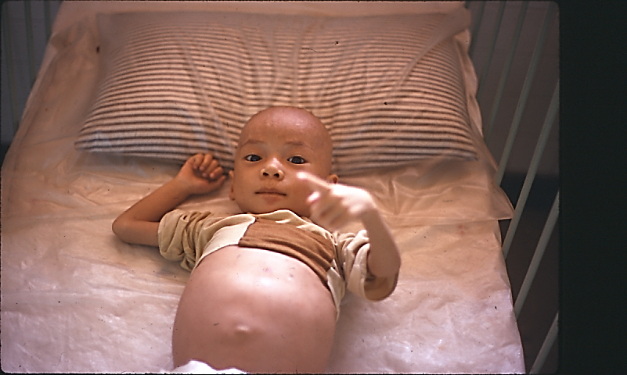
Emaciation and the classic swollen stomach from malnutrition

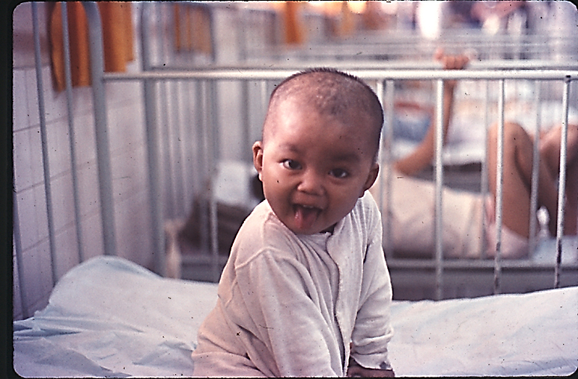
And bouncing back!!
Head lice (pediculosis capitis) was a common secondary diagnosis. If there was no Kwell in stock to treat, and a child’s infestation was easily visible, we had no choice but to shave his or her head.

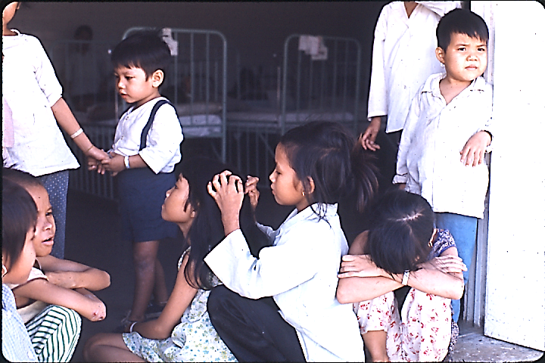
“Nitpicking” lice on the ward - for the girl at right, a head-shave when admitted

Hoa Khanh certainly witnessed the unusual. One morning a toddler was brought to the emergency room with a trickle of blood near his frontal suture. His mother had no explanation, only that it had started during the night. A skull X-ray series was ordered. At the base of his skull, near the foramen magnum, was an intact .223 caliber bullet. Amazingly, the boy was neurologically stable. We theorized a bullet must have been fired into the air miles away (and then having lost all muzzle velocity) entered through the thatch roof of the boy’s home, punctured his cranium, and followed the inner curvature to the foramen? He was immediately transported to the neurosurgical service on one of the hospital ships where the bullet was successfully removed.

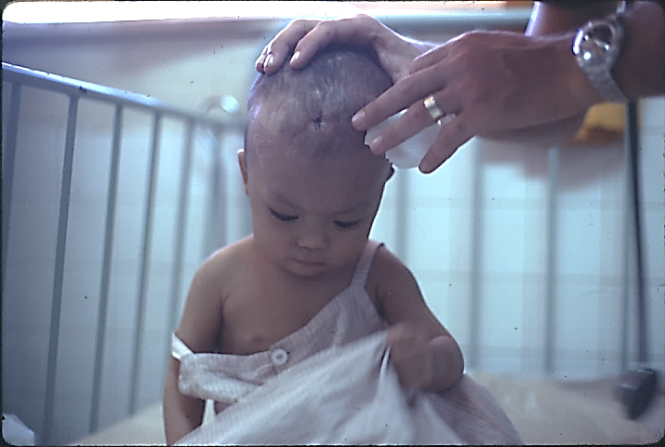
Another Hoa Khanh miracle as described above.
While the survival rate for Hoa Khanh patients was extraordinarily high, the nursery was the most difficult care area in terms of preserving life. Most babies could be acutely malnourished and dehydrated upon arrival; others born prematurely. The prevention of nursery infections and cross contamination of illness was also particularly challenging.

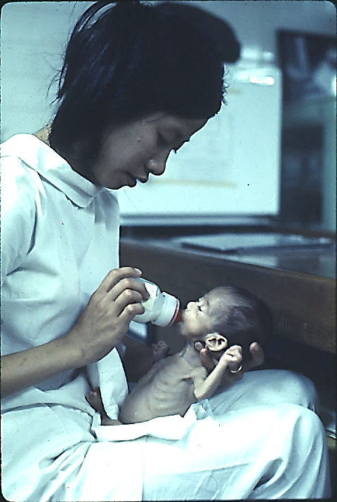
Nursing a “premie”

Cleft palates in varying degrees of severity were not surgically repaired at Hoa Khanh, but could be referred to the hospital ships and then returned to us post-operatively for recovery. Inadequate nutrition during pregnancy, the complete lack of pre-natal care and education, genetic predisposition, and a high frequency in children of Asian descent were all contributing factors within the Vietnamese maternal population. We saw many.

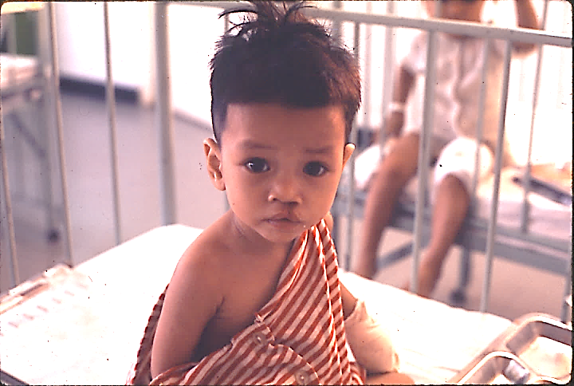
Post-op cleft palate repair (with “mittens” to prevent pulling at sutures)

Patients with directly attributable, war-related wounds and injuries were not daily admissions, but obviously occurred. And some were horrific. The boy in the photo below, as his history was reported to us, was the son of a rural village chief (in the Montagnard region) who was assassinated by the Viet Cong. He had been beaten, shot in the abdomen, and left for dead. He was later found by an army unit, transported for emergency surgery, and eventually sent to us to recover.

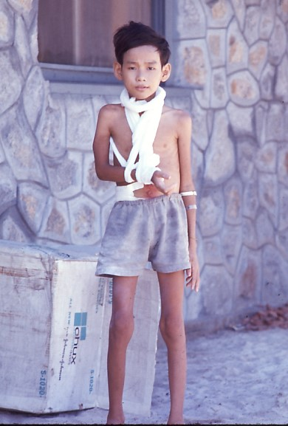
A war victim

While Post Traumatic Stress Disorder (PTSD) is now commonly reported, understood, and diagnosed, I don’t think the Hoa Khanh staff ever realized the extent of the emotional trauma many of our children may have suffered, in addition to their illnesses and injuries, from the daily violence in and around their homes and communities. I do not recall it ever being discussed or considered among the military staff. Yet, their stress must have had a face and every now and then, without realizing, I may have captured the image with my camera.

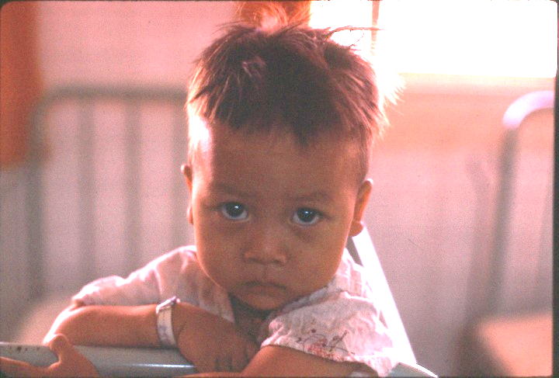
The face of war

The Hoa Khanh patient population had known nothing except war in their short lifetimes. That said, our children could still smile and laugh! If for no other reason than the joy of getting well and knowing they would be going home to their families!

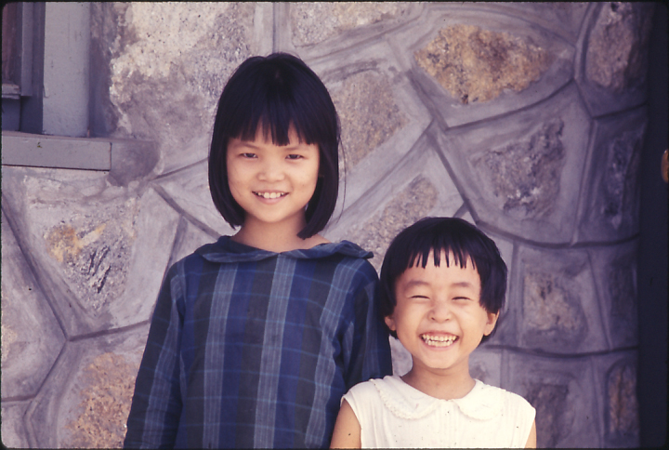
My slide notes say both girls had survived bubonic plague. Worth smiling about!
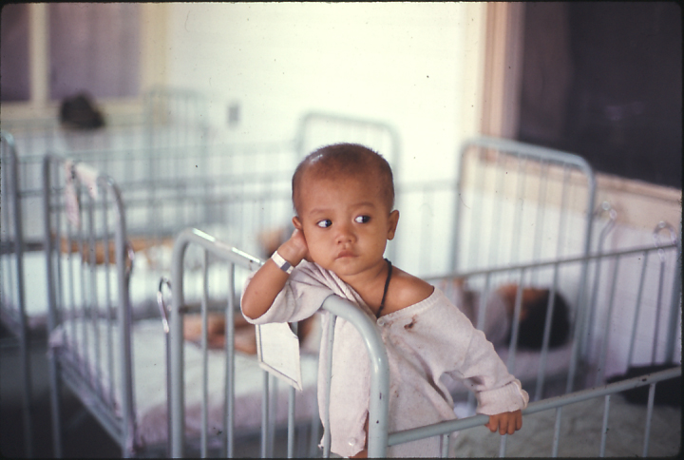
But awaiting discharge could also be just plain boring!

With little more than a Merck Manual and a basic surgical reference text, I can forthrightly say the corpsmen functioned well above the highest of expectations. In reality, there wasn’t any choice. We simply did the very best we could under less than ideal circumstances. The Navy physicians, all of whom had only recently graduated from medical school, were our mentors, teachers, advisers, and confidants. They served double-duty by having to provide care for both Marines and Vietnamese children. None were pediatricians. Unable to spend all the hours they would have liked at the hospital, they put great trust in the corpsmen and Vietnamese nurses to carry out their medical orders. I like to think we rarely failed them or the children we cared for.

From the 1970s to the mid-1990s, following nursing school at Boston University and a return to active duty, I regularly lectured about Hoa Khanh, usually to Navy and Marine Corps medical units, at Field Medical Service School, and occasionally to non-military nursing societies/organizations as well. My presentations could vary depending on the audience. Some were strictly for medical education while others were used to promote the need for humanitarian and civic action projects by US Armed Forces. My only meaningful possession while in Vietnam was my camera. I took approximately 1800 color slides, and they served as the basis for my lectures.

I would often begin my presentations by saying, “The year I spent in Vietnam was the most meaningful of my life and changed forever who I am. If I have achieved any success as a person, a Naval Officer, a health care professional, and a human being, then it can be attributed to the privilege I had of caring for the children at Hoa Khanh.’

Following Vietnam, and with government funding, Charlie Spear completed a Bachelor of Science Degree in Nursing from Boston University and a Masters Degree in Health Services Administration from Webster University. He returned to active duty and retired from the Navy in 1996. He was later employed at Mission Hospital, Asheville, North Carolina before fully retiring in 2012.

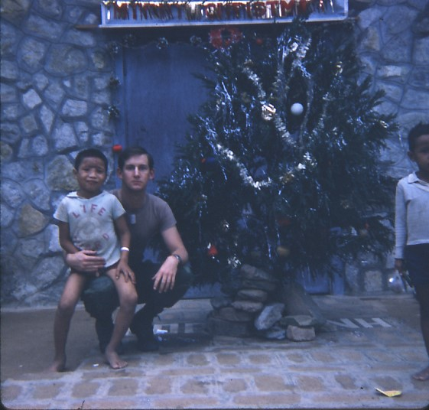
Hospital Corpsman 2nd Class Charlie Spear, Christmas Eve, 1968

